**Cloud Computing**

**Exercise 10 – Cloud Computing and IOT**

1. Please describe the relations between Cloud Computing and IOT.
2. Please describe the opportunities of IOT in 3 dimensions.
3. Please describe the main components in an RFID system based on the following picture.

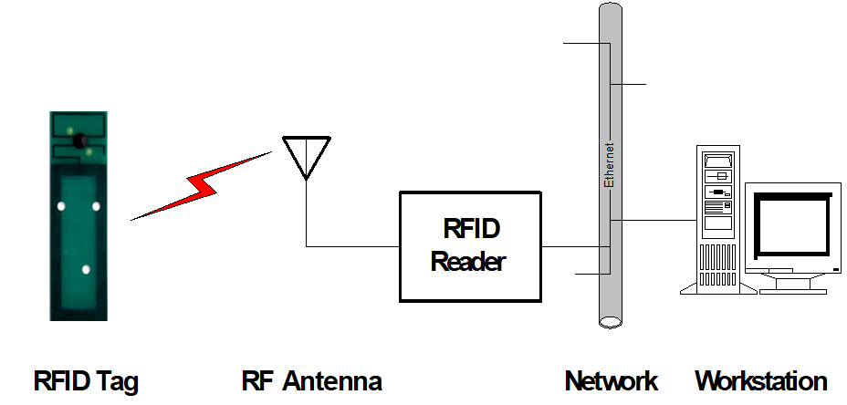

1. Please describe three applications of RFID.
2. Please describe the ALOHA approach for solving tag collisions

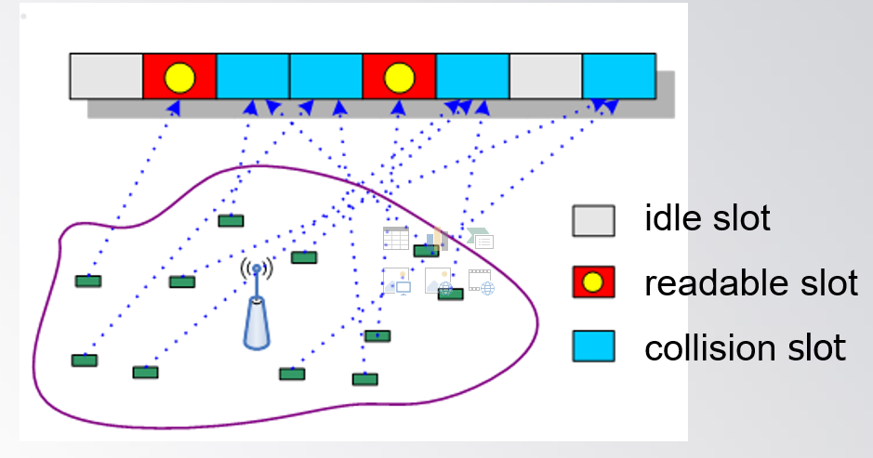

1. Please describe how do sensors form a wireless sensor network.
2. Please describe a typical application of WSN.
3. How does a real-time GPS tracking system work?
4. Please discuss how cloud support the Internet of Things.