**Cloud Computing**

**Exercise 4 - Virtualization**

1. What is virtualization in a computer system?
2. Please describe the virtualization of five abstraction layers.
3. Please analyze the “one to multiple", "multiple to one", and "multiple to multiple" virtualization.
4. Please tell the difference between the following two virtualizations:

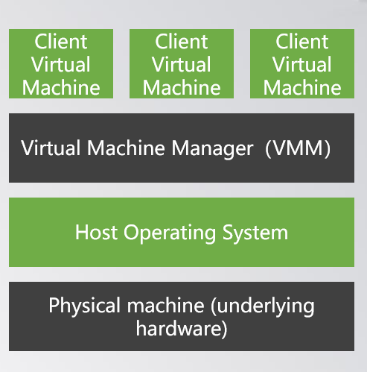 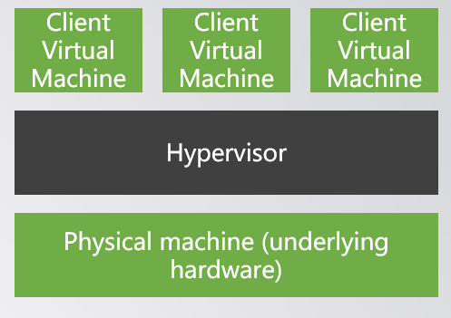

1. Please explain the difference between full virtualization and paravirtualization.
2. Please discuss the address transform in memory virtualization
3. Please describe the procedures of virtual machine migration
4. Please tell us how to combine the different approaches in the following to achieve virtual machine migration

