**Cloud Computing**

**Exercise 5 – Computation Partitioning**

1. What is computation partitioning and its motivation in cloud computing?
2. Based on the following picture to illustrate the divide and conquer idea used in cloud computing.

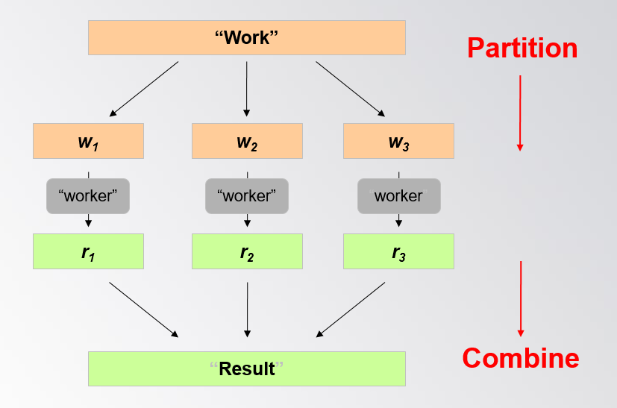

1. Please discuss why not just all the computing in the server side or in the client side?
2. Analyze in the following setting, whether more than twice transmission between the server and the client side will make better result?

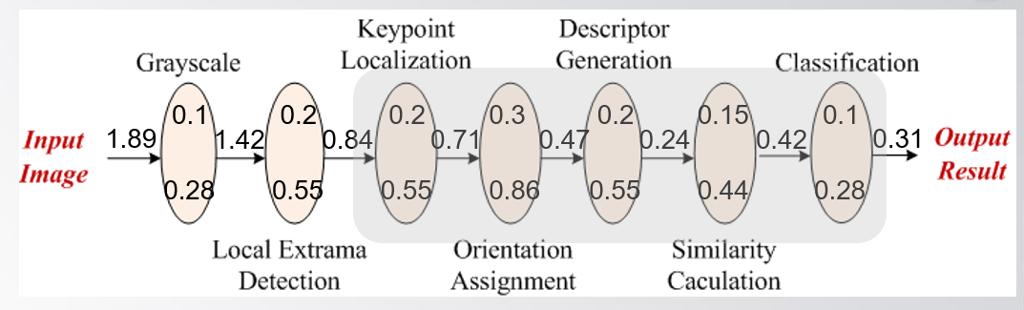

1. Please write codes for the optimal partitioning problem and generate another data set to test your codes
2. Please discuss how to handle the relations among components in the computing diagram?