**Cloud Computing**

**Exercise 6 – MapReduce I**

1. What parallelization problems will we encounter in the cloud computing systems?
2. Please describe the differences between deadlock and livelock.
3. Please discuss how mapReduce helps the developer to simplify the application design.
4. Please compute the result with the following Lisp function:

(fold + 5 '(1 2 3 4 5))

1. Discuss how does the shuffle and sort intermediate results implement in the mapReduce.
2. Please write the pseudo codes of mapReduce for word counting

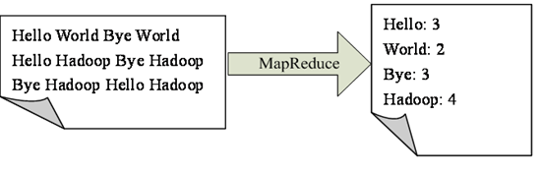

1. Please improve the above codes when we want to find the popular ten words.
2. Write the codes for word sorting using mapReduce.

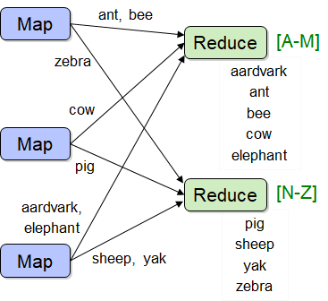

1. How to implement the PageRank using mapReduce in clouds?

Given page *x* with in-bound links *t1…tn*, where *C(t)* is the out-degree of *t*, *α* is probability of random jump, and *N* is the total number of nodes in the graph, we have



