**Cloud Computing**

**Exercise 8 – Service-Oriented Architectures for Cloud Computing**

1. What is service-oriented architecture (SOA)?
2. Please describe the REST architectural style principles.
3. Please based the following picture to show how a web service works.

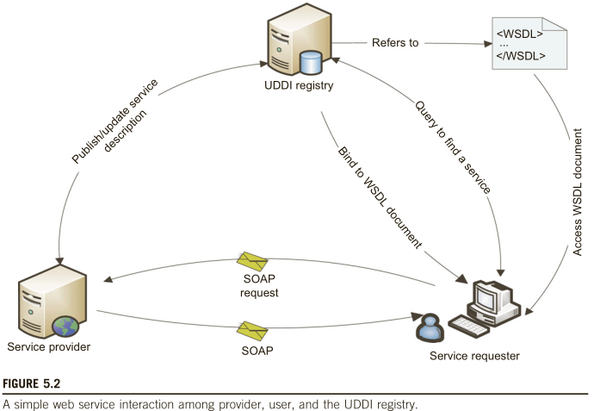

1. Please provide three examples of web services.
2. Please describe the WS-I protocol stack
3. Please discuss the objectives of UDDI and service registries.
4. Please give an example to use workflow in service-oriented architecture.