**Cloud Computing**

**Exercise 9 – Core Algorithms**

1. What problem does the Paxos algorithm solve?
2. How does the Paxos algorithm ensure data consistency?
3. What problem does the DHT algorithm solve?
4. Please provide examples of which distributed systems currently use the DHT protocol.
5. Based on the following picture, please describe how DHT find the key 54, and key 38?

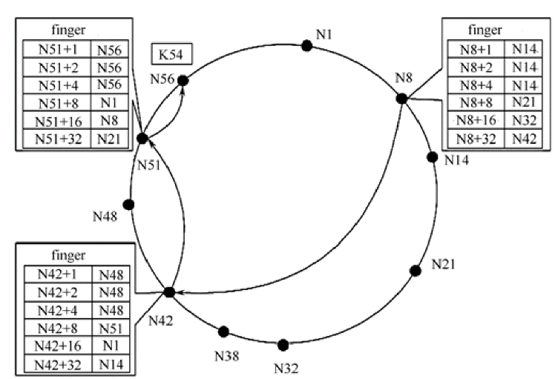

1. In the traditional network protocol hierarchy, where is DHT located?
2. What problem does the Gossip protocol solve?
3. What are the three ways of message propagation in the Gossip protocol?
4. Please draw a schematic diagram of message propagation in the CoolStreaming system.